Reg. No. CODE: SPH1
Ph.D. COURSEWORK EXAMINATION – SEPT/OCT 2023
SUBJECT: BIOTECHNOLOGY
SPECIALIZATION PAPER 1
ADVANCED MOLECULAR BIOLOGY
Time: 03 hours Maximum Marks: 50
Student Name: Drilipta Swain

Instructions:

i) Section A Compulsory
ii) Answer any four questions from Section B
iii) Each question carries 10 Marks

1. a) Explain the concept of mutagenesis in detail using PCR-mediated mutagenesis as an example
b) Elaborate on DNA replication in eukaryotes using suitable illustrations. 5 + 5 = 10 marks

SECTION B

Choose any four questions from this section. Each question carries 10 marks.

2. a) Design the forward and reverse primer (20bp each) for the following full-length sequence:

>Sample CDS
ATGCGAGTGCTCAGCGAGATTGCGGAGTCACCGTTCGTGATTTCTCGGCTAAGCCCTGAT
TCGACGGCCACCGGAGGGTTTATCGGCGGATGGGTCGGGAAGTGTCATGGGTTTCTTCAT
TATCTTCCTCTTTTGTATGTTACTTTTCTTGCAGACTTTTTCCAGGAGGAAGATCTGAAT
TTGGAGAATGTCTACTATTCAGAAATGAAAGATGCTGGATTCTTCGACGCTGATTGGGAA
TAA

b) Describe the process of splicing using illustrations. (5 + 5 = 10)

3. a) Explain qRT-PCR in detail.
b) Illustrate and explain the process of CaCl₂-mediated transformation. (5 + 5 = 10)

4. a) Differentiate between cloning and expression vector using an example each
b) Describe dideoxy (or chain termination) sequencing method. (5 + 5 = 10)

5. a) What is cDNA library? Enlist the steps involved in cDNA library preparation
b) Explain ChIP assay using suitable illustrations (5 + 5 = 10)

6. a) What are molecular markers? Give at least 2 examples.
b) Enlist the steps to clone a gene of interest into the following vector: (5 + 5 = 10)

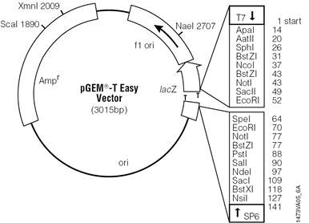

7. Describe the following DNA repair mechanisms:
i. Nucleotide excision repair, ii. Photoreactivation, iii. SOS repair

*********

